Week 15 Homework – Web Vulnerabilities and Hardening

1: *Your Wish is My Command Injection*

/etc/passwd

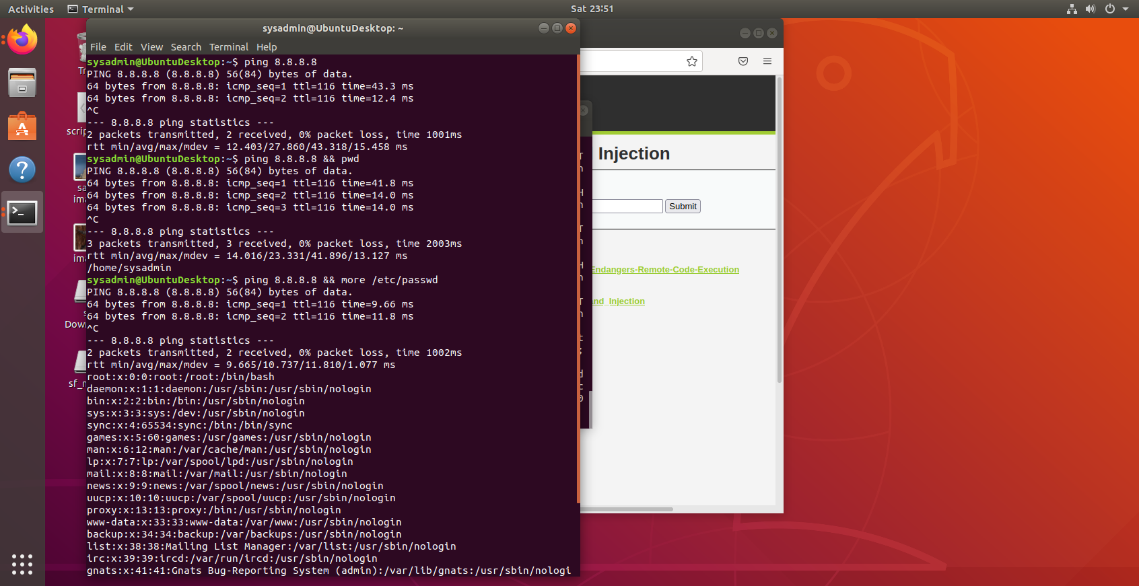

/etc/hosts



*To mitigate the command injection on port 8.8.8.8 you will need to prevent the ip from responding to ping. You may be able to do that by creating a rule that denies and drops incoming and or outgoing ICMP echo requests and responses on ip 8.8.8.8 .*

2: *A Brute Force to Be Reckoned With*

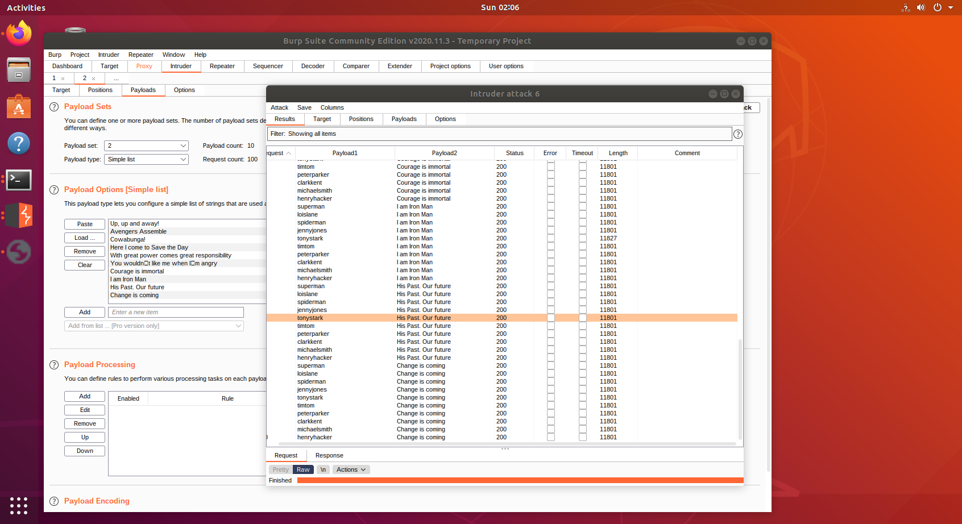

*Burp Suite allows us to grab a page and identify the option and input fields on the page. We can then build a list of option inputs to try and test on each field. Good automation tool for brute force attacks.*

3: *Where's the BeEF?*

*Petty Theft*

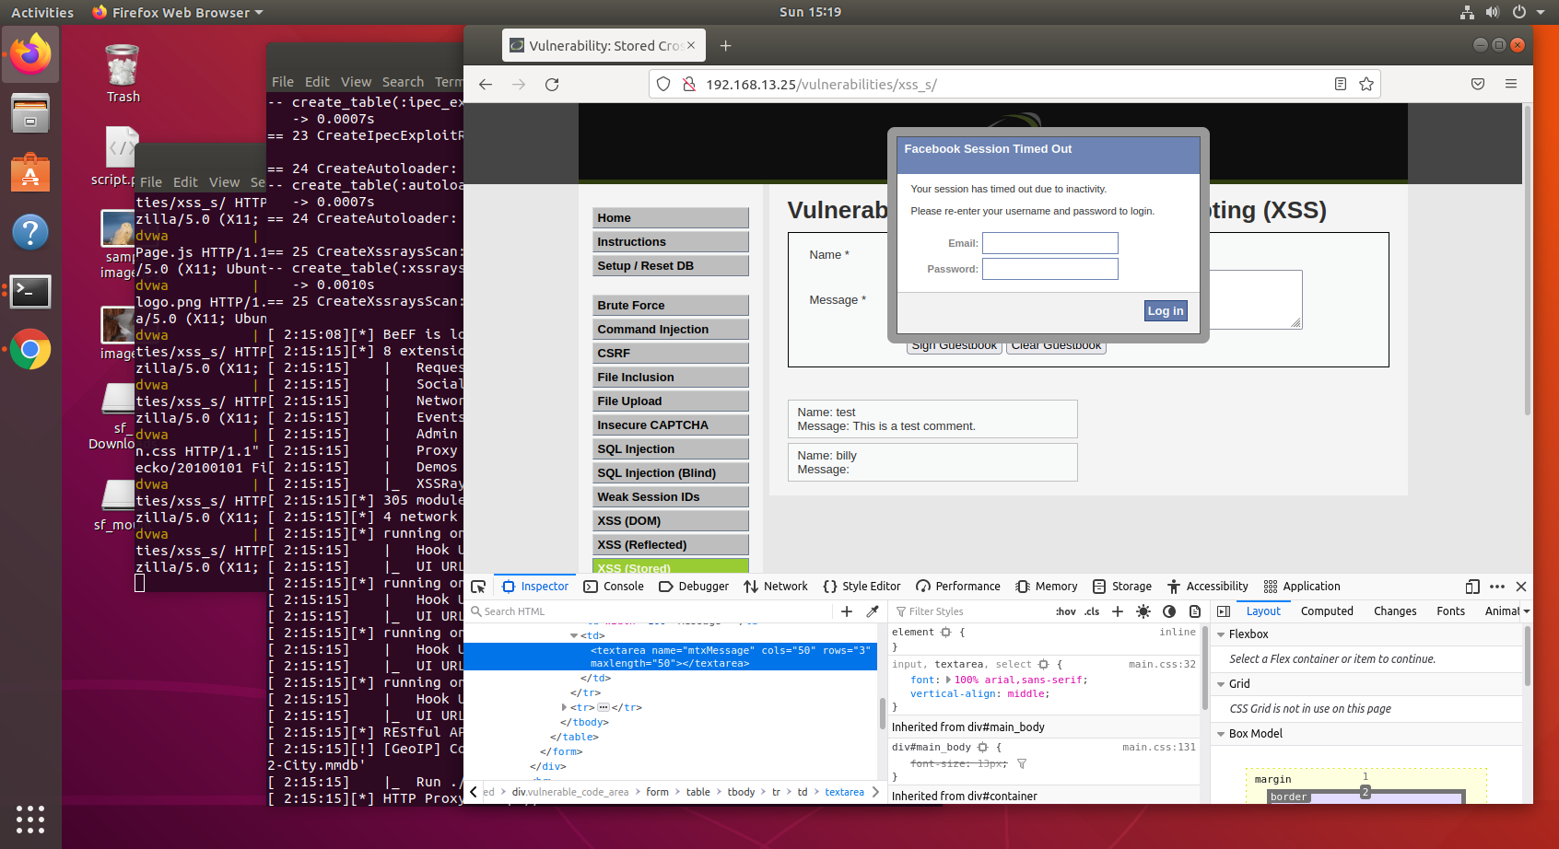

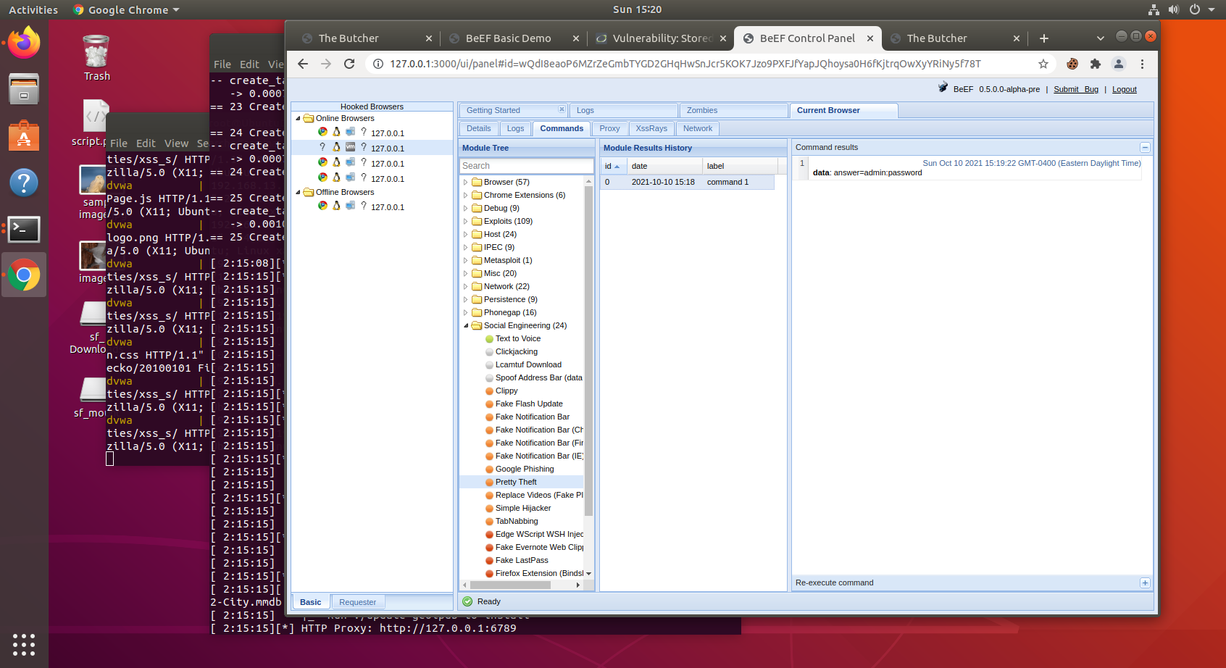

*Fake Notification Bar:*

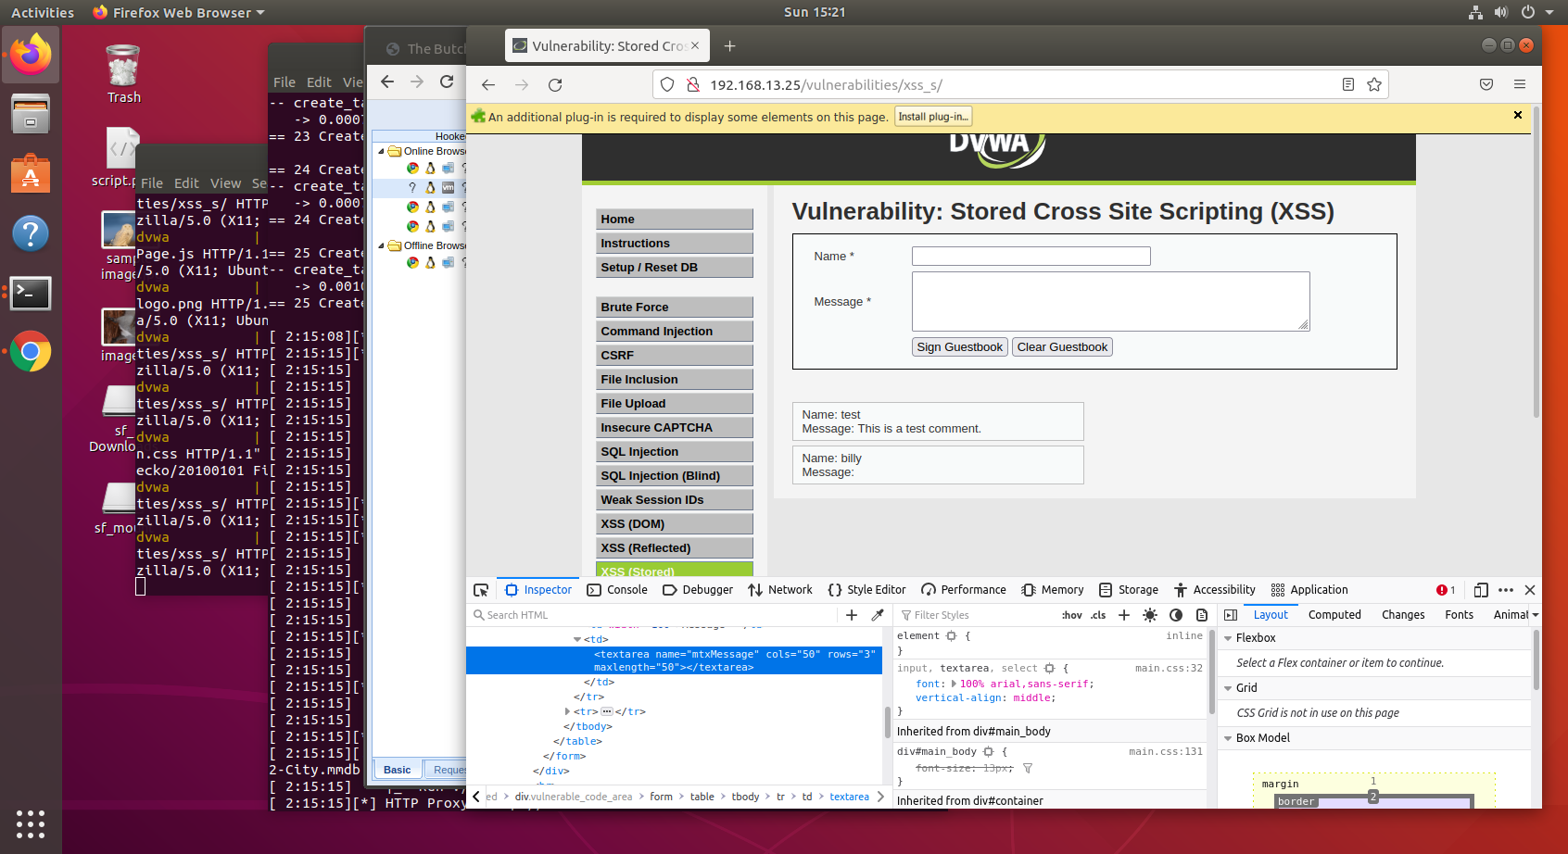

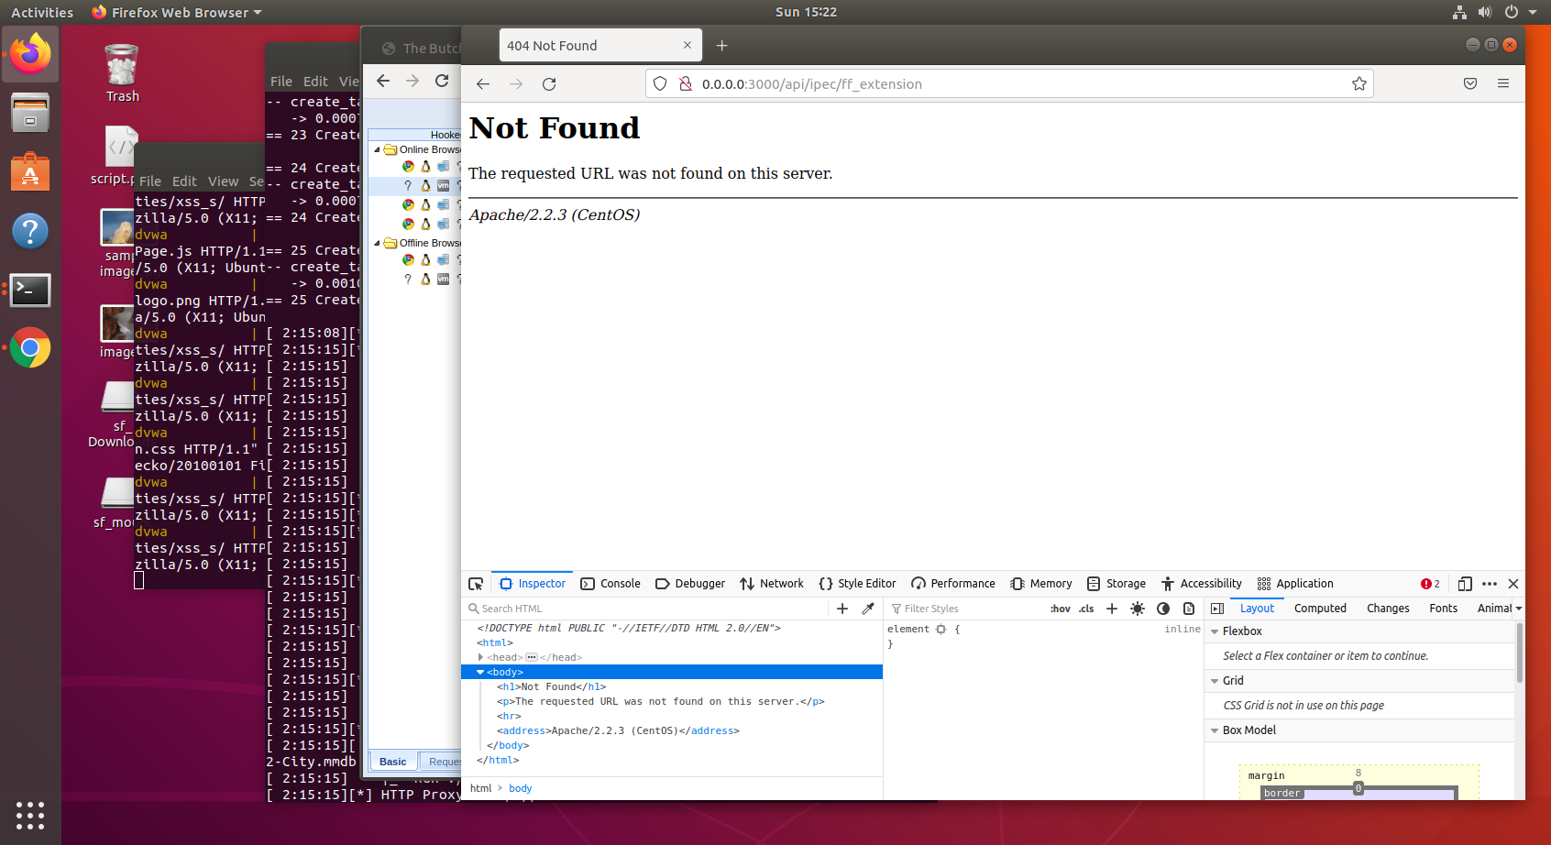

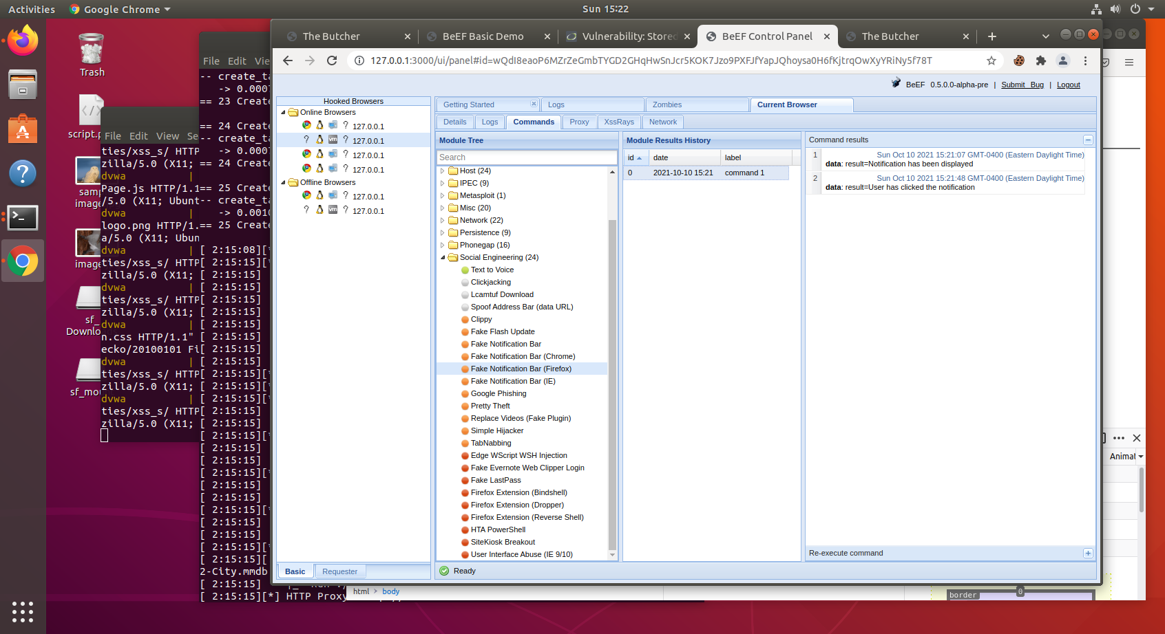

*Detect Google Desktop:*

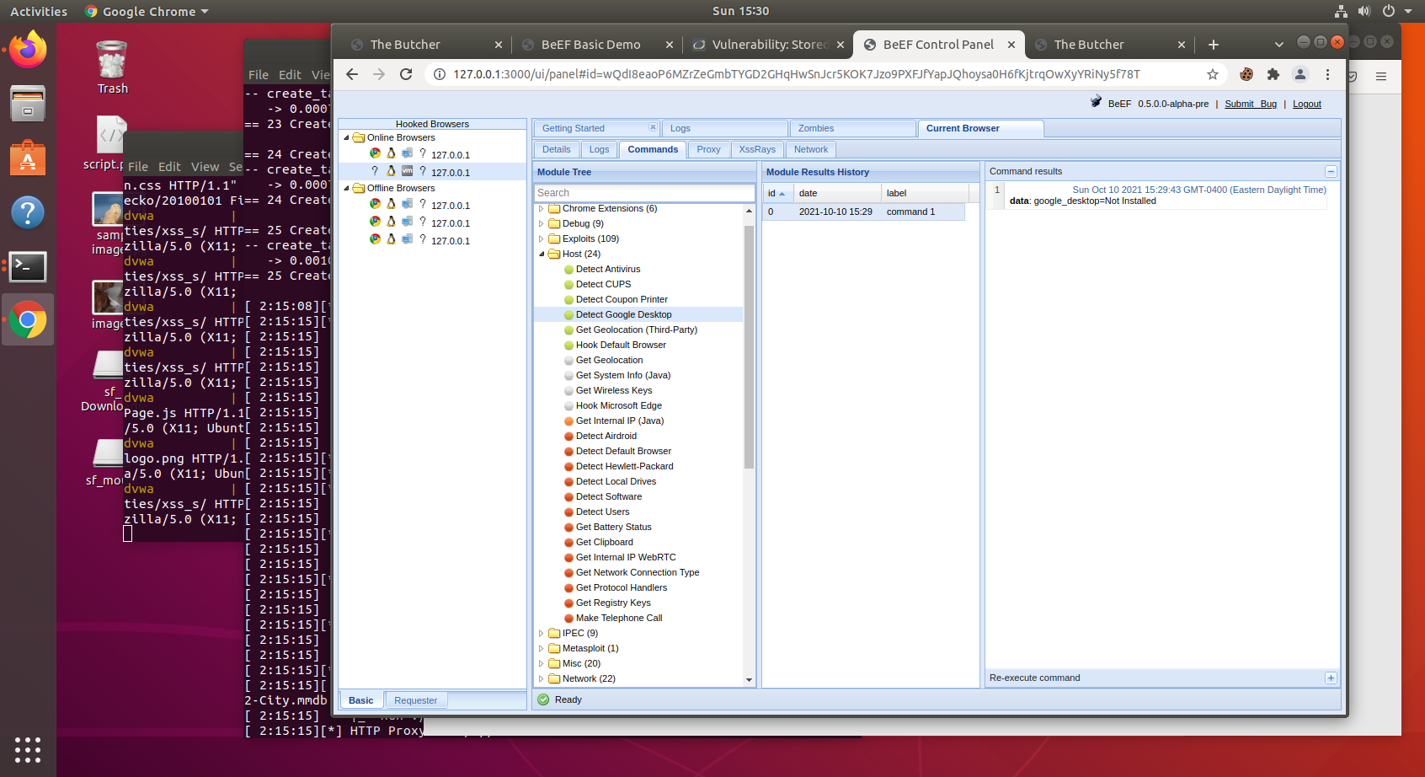

*I am totally impressed with this exercise. I was able to see my location and ip info when I ran Get Geolocation (Third-Party) and lots more information when running other Host options. Wow! Totally impressed with how much info you can garner from hooking a browser.*

*Sid*